|  |
| --- |
| 新东方在线英语学习 |
| 新概念 1 册 |
| Lesson19-20 |



扫一扫。更多有趣的英语资讯。

# Lesson 19 单词讲解

1. matter: n. 事情What’s matter? What’s the matter?
2. children: 孩子们

child 孩子 chai ao de

kid- kids ki zi

1. tired: adj. 累，疲乏

I am tired.

Are you tired?

I am not tired.

1. boy: n. 男孩
2. thirsty: adj. 口渴的sir si tei

He’s thirsty.

1. Mum: 妈妈
2. sit down: 坐下

Sit down, please. Have a seat.

1. right: 好，可以

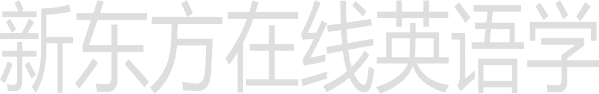All right.

1. ice cream: 冰激凌

# Lesson 19 课文讲解

1. 又渴又累

tired and thirsty 又好看又善良beautiful and kind 又高又帅

tall and handsome 又年轻又有钱young and rich

1. There’s an ice cream man.

那有一个卖冰激凌的人。

There be(is\ are) 句型那有一个快递员。There’s a mailman.

1. Two ice creams, please.

买两个冰激凌。

n. + please

1. These ice creams are nice. 这些冰激凌真好吃。这个冰激凌真好吃。This ice cream is nice.

# Lesson 19 语法讲解

1. 复数& 句子

Those children tired.

We

This child

thirsty.

very young.

children are tired.

mother is busy.

friends are tall.

brother is a taxi driver.

# Lesson 20 单词句型讲解

1. big: 大的

风大、雨大、雪大：heavy hai v

声音大：loud

年纪大：old 面积大：large

1. small: 小的
2. open: 开着的

The door is open

Sha te.

1. shut: 关着的

The window is shut.

1. light: 轻的
2. heavy: 重的
3. long: 长的 lang 嗯。。。。

时间、东西a long time a long knife

1. shoe: 鞋 shu wu...

a shoe: 一只鞋

a pair of shoes: 一双鞋

1. grandfather: 祖父、外祖父
2. grandmother: 祖母、外祖母
3. in- law 结婚后的亲属关系
4. Aunt 姨妈 ang te

mother in-law

father in-law

sister in- law 嫂子

brother in- law 姐夫

1. step 后的，继的si dai pu

step mother step father step sister

1. ex- 前任的aikesi

ex-girlfriend ex-boyfriend ex-wife

ex-husband

# 字母组合-4

/a ʊ/ ai ou

# Lesson 19&20 知识拓展

o w /a ʊ/

now /n a ʊ/n ai ou

how /h a ʊ/ hai ou

cow /k a ʊ/k ai ou

allow /ə ’la ʊ/

/ə ʊ/e ou

o w

/a ʊ/ai ou

o u/a ʊ/

house /h a ʊ s/ b louse /b l a ʊ z/ bu lai ou z



cloudy /k la ʊ d I/k lai ou dei found/f a ʊ n d/f ai ou n de

/ɔ I/ao yi

/ɔ I/ o y

toy /t ɔ I/ boy/b ɔ I/

joy /ʤ ɔ I/ oyster/’ɔ I s t ə/ao yi si ter

/ɔ I/o i

oil/ ɔ Il/ao yi ao coin/c ɔ In/kao yi n

moist /m ɔ I s t/ noise/n ɔ I z/nao aizi

/I ə/ye er

注意：

/I ə/ /I r/ ear /I ə/

dear /d I ə/ near /n I ə/ fear /f I ə/ hear/h I ə/ 例外：

early,er lei earth, er si earn/ə:/ /ɜ:/ er n

/I ə/ee r

deer/ d I ə/ beer /b I ə/ steer /s t I ə/ jeer/ʤ I ə/

/e ə/ai er

注意：

/e ə/ /e r/ /ɛ ə/ air /e ə/

air /e ə/ fair /f e ə/

hair /h e ə/ pair /p e ə/

/e ə/ ear

wear /w e ə/ rear/r e ə/ pear /p e ə/ fear/f e ə/

/I ə/

ear /e ə/

/ə: /

/a ʊ/ /I ə/

/ɔ I/ /e ə/

o w o u /a ʊ/

o y o i/ɔ I/ ear e e r /I ə/ air ear/e ə/



霍娜

微信：Tophuona